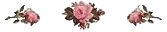

Mrs. Christine Braun requests the pleasure of your company at high tea on Friday, the 16th of February.
Please bring your Valentine’s to share!

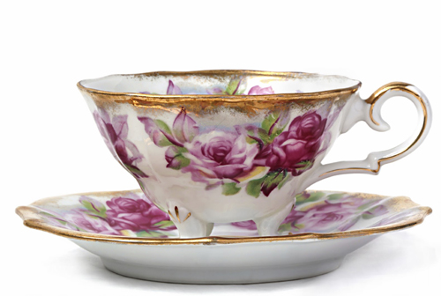

Politeness at the Table
For a very pleasant social affair the rule is not to have the company when seated exceed twelve in number. With a party of that size the conversation can be general, and all are likely to feel more at ease than if the number be larger, provided a selection of guests is made that are congenial to each other. None of them should be conspicuously superior to the others, and all should be from the same circle of society.
It is of the utmost importance that all of the company be punctual, arriving from ten to fifteen minutes before the appointed time. To be ten minutes late, keeping the dinner waiting, is a serious offense which no one should be guilty of. The host, hostess and other members of the family should be early in.
Gentility in the Dining Room
The evidence of good breeding with a party of ladies and gentlemen seated about a table, who are accustomed to the usages of polite society, are many. Among these will be the fact that the table is very beautifully and artistically spread. This need not require much wealth, but good taste is necessary to set it handsomely.
Again, the company evidences gentility by each assuming a genteel position while eating. It is not necessary that an elaborate toilet be worn at the table, but careful attention should always be given to neatness of personal appearance, however plain may be the dress which is worn.
Another evidence of good manners is the self-possession with which the company deport themselves throughout the meal. The drawing-room is to receive guests as they arrive, each of whom should be welcomed with a warm greeting.
Proceeding to the dining-room when all is ready, the host will take his seat at the foot of the table, and the hostess at the head, the lady escorted by the host taking her seat at his right, and the escort of the hostess sitting also at her right. The next most honored seat is at the left of the hostess.
It is fashionable to have cards laid upon the table, bearing the name, sometimes printed very beautifully upon silk, indicating where each guest shall sit, which saves confusion in being seated. The ladies having taken their places, the gentlemen will be seated, and all is in readiness for the dinner to be served, unless grace be said by a clergyman present or by the host.
No polite guest will ever fastidiously smell or examine any article of food before tasting it. Such conduct would be an insult to those who have invited him; neither will the host or hostess apologize for the cooking or find fault with each other, the cook or the waiters; all having done the best they could, there is nothing left to do but to make the best of everything that is provided.
Special pains should be taken by the host and hostess, as well as all the company, to introduce topics of conversation that shall be agreeable and pleasing, that the dinner hour may be in the highest degree entertaining. When all the guests have finished their eating, the hostess, with a slight nod to one of the leading members of the party, will rise, as will all the company, and repair to the drawing-room, where, in social converse, the time should be spent for the next two or three hours. Etiquette demands that each member of the company remain at least an hour after the dinner is finished, it being impolite to hurry away immediately after rising from the table. Should he do so, however, he will ask to be excused.
Correct and Incorrect Positions
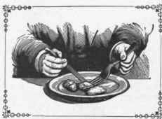

HEREWITH is shown a fault common with many people of holding knife and fork above the hand when mashing potatoes, cutting meat, etc. The position is not only unfavorable for obtaining a good command of knife and fork, but it is likewise ungraceful. The contrasting illustration represents an easy, graceful posture for hands, when eating. The habit of holding the hands thus in correct positions can be acquired as easily as any other.

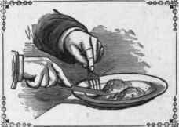

It is well to become accustomed to eating with the left hand, so as to avoid the necessity of changing the fork from the left to the right hand frequently when eating meat. When no knife is required for spreading, mashing or cutting, lay it aside entirely and eat only with the fork, holding it with the right hand.
Actions Which Indicate Bad Manners When Eating
DO NOT speak disrespectfully to the waiters, nor apologize to them for making them trouble; it is their business to bring forward the food called for. It is courtesy, however, when asked if you desire a certain article, to reply, "If you please;" "Not any, I thank you," etc.; when calling for an article, to say, "Will you please bring me," etc.; and 'when the article has been furnished, to say, "Thank you."
Never eat very fast.
Never fill the mouth very full.
Never open your mouth when chewing.
Never make noise with the mouth or throat.
Never attempt to talk with the mouth full.
Never leave the table with food in the mouth.
Never soil the table-cloth if it is possible to avoid it.
Never carry away fruits and confectionery from the table.
Never use anything but fork or spoon in feeding yourself.
Never explain at the table why certain foods do not agree with you.
Never introduce disgusting or unpleasant topics for conversation.
Never pick your teeth or put your hand in your mouth while eating.
Never cut bread; always break it, spreading with butter each piece as you eat it.
Never express a choice for any particular parts of a dish, unless requested to do so.
Never hesitate to take the last piece of bread or the last cake; there are probably more.
Never use your own knife when cutting butter. Always use a knife assigned to that purpose.
Never wipe your fingers on the table-cloth, nor clean them in your mouth. Use the napkin.
Never, when serving others, overload the plate nor force upon them delicacies which they decline.
Never make a display of finding fault with your food. Very quietly have it changed if you want it different.
Never pass your plate with knife and fork on the same. Remove them, and allow them to rest upon a piece of bread.
Never make a display when removing hair, insects or other disagreeable things from your food. Place them quietly under the edge of your plate.
Never tip back in your chair nor lounge upon the table; neither assume any position that is awkward or ill-bred.
Never, at one's own table or at a dinner-party elsewhere, leave before the rest have finished without asking to be excused. At a hotel or boarding house this rule need not be observed.
Never expectorate at the table; also avoid sneezing or coughing. It is better to arise quietly from the table if you have occasion to do either. A sneeze is prevented by placing the finger firmly on the upper lip.
Never permit yourself to engage in a heated argument at the table. Neither should you use gestures, nor illustrations made with a knife or fork on the table-cloth.
Never put your feet so far under the table as to touch those of the person on the opposite side; neither should you curl them under nor at the side of your chair.
Never praise extravagantly every dish set before you; neither should you appear indifferent. Any article may have praise.

Errors to Be Avoided
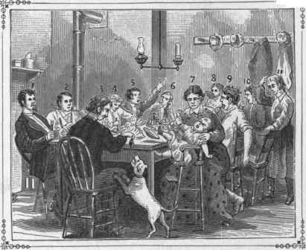
l. Tips back his chair.
2. Eats with his mouth too full.
3. Feeds a dog at the table.
4. Holds his knife improperly.
5. Engages in violent argument at the meal-time.
6. Lounges upon the table.
7. Brings a cross child to the table.
8. Drinks from the saucer, and laps with his tongue the last drop from the plate.
9. Comes to the table in his shirt-sleeves, and puts his feet beside his chair.
10. Picks his teeth with his fingers.
11. Scratches her head and is frequently unnecessarily getting up from the table.
Eating With the Fork
Fashions continually change. It does not follow, because he does not keep up with them, that a man lacks brains; still to keep somewhere near the prevailing style, in habit, costume and general deportment, is to avoid attracting unpleasant attention.
Fashions change in modes of eating. Unquestionably primitive man conveyed food to his mouth with his fingers. In process of time he cut it with a sharpened instrument, and held it, while he did so, with something pointed. In due time, with the advancement of civilization, there came the two-tined fork for holding and the broad-bladed knife for cutting the food and conveying it to the mouth. As years have passed on, bringing their changes, the three and four-tined forks have come into use, and the habit of conveying food with them to the mouth; the advantage being that there is less danger to the mouth from using the fork, and food is less liable to drop from it when being conveyed from the plate. Thus the knife, which is now only used for cutting meat, mashing potatoes, and for a few other purposes at the table, is no longer placed to the mouth by those who give attention to the etiquette of the table.
Rules to Be Observed
Sit upright, neither too close nor too far away from the table.
Open and spread upon your lap or breast a napkin, if one is provided - otherwise a handkerchief.
Do not be in haste; compose yourself; put your mind into a pleasant condition, and resolve to eat slowly.
Keep the hands from the table until your time comes to be served. It is rude to take knife and fork in hand and commence drumming on the table while you are waiting.
Possibly grace will be said by some one present, and the most respectful attention and quietude should be observed until the exercise is passed.
It is the most appropriate time, while you wait to be served, for you to put into practice your knowledge of small talk and pleasant words with those whom you are sitting near. By interchange of thought, much valuable information may be acquired at the table.
Do not be impatient to be served. "With social chitchat and eating, the meal-time should always be prolonged from thirty minutes to an hour.
Taking ample time in eating will give you better health, greater wealth, longer life and more happiness.
If asked at the next course what you desire, you will quietly state, and upon its reception you will, without display, proceed to put your food in order for eating. If furnished with potatoes in small dishes, you will put the skins back into the dish again; and thus where there are side-dishes all refuse should be placed in them - otherwise potato-skins will be placed upon the table-cloth, and bones upon the side of the plate. If possible, avoid putting waste matter upon the cloth. Especial pains should always be taken to keep the table-cover as clean as may be.

