Name: _____________________________________
Period: _________________
Date: ___________________

NHD 2019

Theme: Breaking Barriers
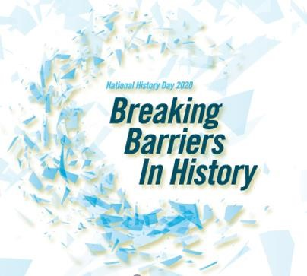
Topic and Thesis
Assignment
DUE: Wednesday 10/23/19

DUE: Contract signed 10/23
DUE: Historical Significant Activity on 10/23

FINAL TOPIC SELECTION SHEET NAME: DUE:
- This year’s History Day theme is “Breaking Barriers in History”.

- My broad topic choice is ______________________________________________________

I am interested in this topic because _______________________________________

This topic relates to the theme because _____________________________________

- I have narrowed my broad topic by focusing more specifically on _______________________
__________________________________________________________________________________
- I am confident that I will be able to find the sources I need because ______________________
___________________________________________________________________________________
- Through my research I’m trying to answer questions in three areas:
Person/Idea/Event/Issue-What are the five W’s of my topic? (Who? What? When? Where? Why?) Can I clearly explain the relationship of my topic to the theme?
Background/Context- What was happening in history just before and at the time of the person/idea/event/issue I’m researching? What events led up to my topic? What factors contributed to the development of my topic?
Impact/Influence/Change – So what? How did my topic alter history? What changes did my topic bring about? How did my topic affect individuals, communities, nations, or the world? Can I explain the significance of my topic over time?

Of the three areas, the one about which I have the most information at this time is ________________

because ______________________________________________________________________________

Of the three areas, the one about which I am the most uncertain is ___________________________

because _______________________________________________________________________________

- What I like best about my topic choice is _________________________________________________

- My biggest concern about my topic choice is ______________________________________________
PLACING MY TOPIC IN THE BIG PICTURE - HISTORICAL CONTEXT

CHALLENGES:

ALTERNATE PERSPECTIVES:

Social
&
Cultural

Climate of the Time P
eriod
:
(
describe
)

Key People in the Time
Period
:

MY TOPIC

Arts, Entertainment,

Lit
erature,
Athletics:

Main Events Which Occurred

Right
B
efore

My Topic
:

Political Climate:

(
Briefly describe
)

Country:

World:

Economic Conditions:

(
Briefly Describe
)

Country:

World:

Science & Technology of the Period
:

PLACING MY TOPIC IN THE BIG PICTURE - HISTORICAL CONTEXT
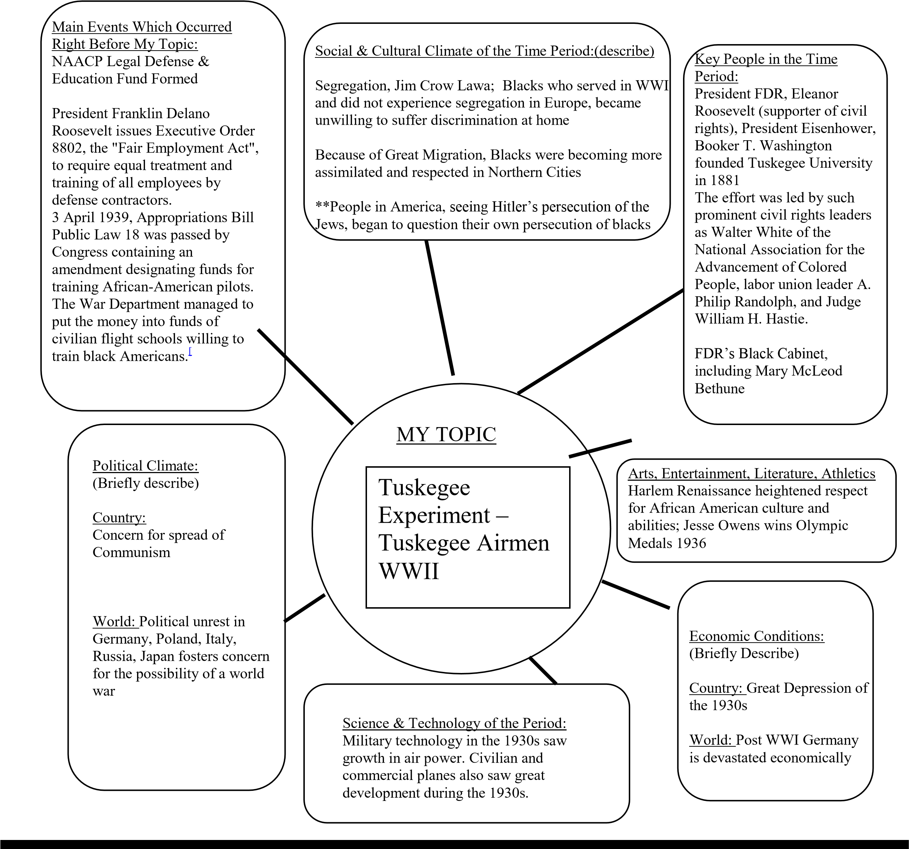

CHALLENGES: From all accounts, the training of the Tuskegee Airmen was an experiment established to prove that "coloreds" were incapable of operating expensive and complex combat aircraft. Stationed in the segregated south, the black cadets were denied rifles. Tests given the blacks were designed to show their incapability, but the airmen showed they were ready and capable of serving in the military.
Pres. GW Bush said of the airmen, when awarding medal recently, "They were fighting two wars. One was in Europe, and the other took place in the hearts and minds of our citizens."

ALTERNATE PERSPECTIVES: Some civil rights activists feared that a separate unit of blacks would further segregate the military.
After you have conducted some research, begin a working draft of your thesis statement. It is a "working draft" because it can change over the course of your research. Write a "working draft" of your thesis statement for your National History Day project below. This is your opportunity to receive feedback from your teacher.

HINTS:

- Use the key words from this year’s theme (Breaking Barriers in History) in your thesis statement.
- Find out what others have said about this event or issue and focus your research either to prove or disprove their arguments.
- Be open to new ideas as you research. Don’t be afraid to prove your hypothesis wrong. You can always revise and refine the thesis statement to reflect your findings later.

2014 “Rights & Responsibilities in History” Thesis Statement Examples
background topic rights (theme words) responsibilities immediate impact long-term significance

I. “Tuskegee Experiment: No Rights, Plenty of Responsibilities”
In the segregated 1930s, when blacks were considered physically and mentally inferior to whites, the Tuskegee Experiment was created as a back-up plan in the event of a national emergency. Even though they did not yet have civil rights amongst their countrymen, the Tuskegee Airmen took on the responsibility of defending their country during WWII. The Airmen’s success led to President Truman’s 1948 executive order 9981, with the U. S. Air Force becoming the first service to soar above the color line. Today, 40% of America’s military personnel is non-white.

II. “Mississippi Institute: Providing the Right to Learn”
Three decades before Helen Keller made her breakthrough understanding of ‘water’ (1884), and at a time when there were very few educational opportunities for deaf people, the Mississippi Legislature established the Mississippi Institution for the Deaf and Dumb (March 1, 1854) in Jackson, Mississippi. Because it was believed that all students deserved the right to learn and communicate, the Mississippi Legislature took the responsibility to provide that opportunity. At first instructors were difficult to find, but the Institution currently serves 150 students each year and has prepared many to attend universities, including Gallaudet University in Washington, D.C.

III. “Phillip Martin: Mississippi Choctaw’s Moses”
After they somehow survived Indian Removal in 1830, the Indian Reorganization Act of 1945 gave the Mississippi Choctaw Indian Tribe the right to settle in Neshoba County. However, they continued to struggle economically due to bigotry, cultural isolation, and lack of jobs. In 1960, Phillip Martin, who was later called the ‘Moses of the Choctaw’, took responsibility to help his people restore their culture. Serving in leadership for nearly 5 decades, Martin took the Mississippi Band of Choctaw Indians from abject poverty to prosperity.

IV. “President Truman: Military Right and Responsibility”
As World War II raged on, there was great debate at the highest levels of the United States Government regarding the use of the atomic bomb. President Truman, taking the responsibility to minimize the loss of human lives, made the decision that he also had the right to accomplish that by any means possible. The dropping of the atomic bomb in Japan ended World War II, and began the Atomic Age.

