Stephen P. Covert, Ph.D., Principal
Pine View School
1 Python Path • Osprey, Florida 34229 (941) 486-2001 Fax (941) 486-2042
https://sarasotacountyschools.net/schools/pineview

Melissa Abela, Assistant Principal

Tricia Allen, Assistant Principal of Curriculum
Katelynn Marcotte, Assistant Principal

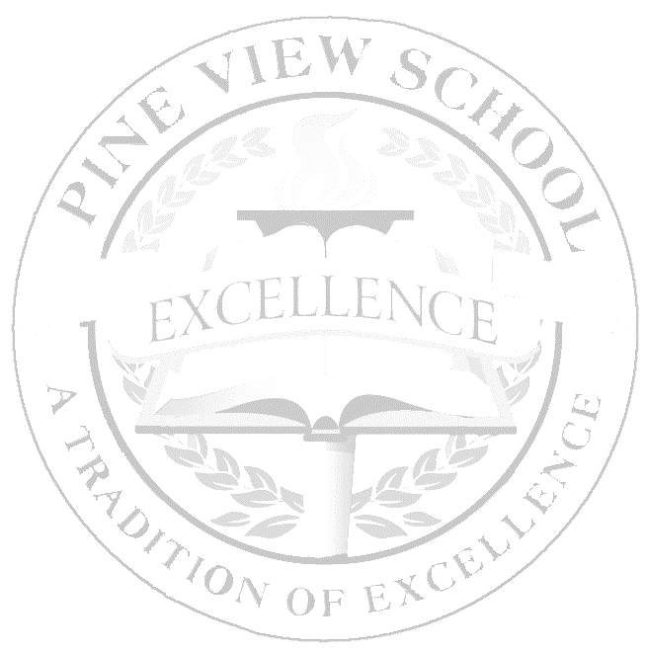

WORLD HISTORY HONORS COURSE EXPECTATIONS 2020-2021
Mrs. Braun
MLC #12

Welcome to 9th grade World History Honors. You will develop skills for studying historical people and events to explore reasons why they are important to us today: utilizing past examples in addressing present and future issues. A variety of historical topics from differing perspectives will be presented to broaden students’ world-view.

Course Content

This class is an in-depth study of world history to enable students to understand their connections to the development of civilizations by examining the past to prepare for their future as participating members of a global community. Students will use knowledge pertaining to history, geography, economics, political processes, religion, ethics, diverse cultures, and humanities to address academic, civic, social and some employment issues.

- Textbook: World History and Geography by McGraw Hill, 2018. ISBN 139780076767953. While the textbook is the main source used, to meet the intent of the standards as well as the rigor expected by the state of Florida other materials will be used in this course as well. These materials are aligned to the standards of the course set forth by the State of Florida. Supplementary materials may include but are not limited to all resources purchased by the Sarasota County School District; repositories such as news media, Youtube videos and movies; Hist. Chan, TedEd and Crash Course.

Blackboard: Blackboard is an application for online teaching, learning, community building, and knowledge sharing. You will be using blackboard in class. In order to access Blackboard you will need your N Number and pin number to log in. You can access it at the following website: https://learn2.sarasota.k12.fl.us/

General Policies:
Check regularly my website (found through the school web page) has most homework.
Changes will be noted orally and on the board in class.
The School Progressive Discipline plan will be followed.
Sarasota County/school grading policy will be in effect.
Reading/notes/homework is due the day after assigned unless otherwise instructed.
No monetary donations are required.
Respect- treat the subject matter, instructor, classroom materials, other students and their opinions
with respect (demonstrating consideration and appreciation).

Electronics: Cell phones may be used for instructional purposes only. Instructors will direct students to take out and put away their devices as needed. At all other times, cell phones and earbuds should not be visible/utilized during the instructional period. Teachers may elect to collect electronics during assessments or as part of their classroom procedures. Unauthorized cell phone use during class time may result in a discipline referral.

Grading:
Tests/Projects 60%
Classwork/Homework 20%
Participation/organizational/employability skills 20%

Part/org/emp skills include, but are not limited to:
-attendance
-come to class on time
-bring required work tools such as paper, notebooks, & etc.
-attitude, cooperation and participation in discussions
-time in class is devoted to the appropriate task

Homework and Make-up Work: See my website via the school web site’s Staff Directory. Homework is listed weekly on the WHH page. Following district guidelines, students are responsible for making up any work missed from absence, asking about what materials and work has been missed and making any necessary arrangements with the teacher. You must make up all work within a reasonable time, but that does not mean you may wait until the end of the quarter. You are expected to complete all make-up work for a unit before the next test. Make-up tests will not be given during class, you must make tests up at the end of the day.

After School Help: I am available for a conference 7th period. Please make an appointment to see me. I am also available through e-mail at the following addresses: Christine.Braun@sarasotacountyschools.net

Supplemental Materials - While the textbook is the main text that is used in this course, in order to meet the intent of the standards as well as the rigor expected by the State of Florida other materials including primary source documents, political cartoons, maps, charts, videos, and graphs from repositories such as the list below may be used with in the classroom. Videos from Safari or our other Learning Resources (GALE, World Book, You Tube for Education, etc.) as well as anything packaged within digital textbook resources, may be used in our class as well. Each of these materials is aligned to the standards of the course set forth by the State of Florida.

Purchased by the District:
PBS Learning
Safari Montage
Sarasota Herald Tribune
ESources for High School
Global Issues in Context
Opposing Viewpoint in Context
Sources in US History The Civil War
US History in Context

Communication: If you have concerns or questions, you may contact me by email at Christine.Braun@sarasotacountyschools.net and if it is a week-day I will likely respond to you within hours or call the school 486-2001 to speak with me (work periods are 3rd & 7th). Visit my website via the school website and my name under ‘Staff’.

Plagiarism: It is taking someone else’s work or ideas and passing them off as your own a.k.a copying, paraphrasing, ‘cribbing’, pirating, theft and stealing. Plagiarism results in a ‘0’ and a referral. See Perdue Owl or Easybib for parenthetical (in-text) and MLA citation form.

In WHH, “The true measure of success is not to outdo others, but rather to outdo ourselves.” At Pine View and in my classroom, this message underscores our 212̊° philosophy. To be successful in my classroom, putting forth extra effort, the extra degree will have a guaranteed outcome – you will “outdo yourself!” By setting some personal academic goals in this class and then following a plan to achieve them, you will leave this course satisfied and proud of your accomplishments.

“I will uphold the honor code and I understand the consequences if I choose academic dishonesty.” Note: not signing will not excuse student from consequences if s/he chooses to be dishonest.

Sign below to acknowledge having read and understood this Course Expectations.

Electronic Signature: Please go to the link below and fill out and digitally sign that you (the parent/guardian) have read through the syllabus and understand the expectations of this course.

https://forms.office.com/Pages/DesignPage.aspx?auth_pvr=OrgId&auth_upn=A044308@sarasotacountyschools.net&origin=OfficeDotCom&lang=en-US#FormId=E9pxtx3TRUedpjocyHRS0YHv_b0DsG1OsfXPOmUWIIdUOFpMRDhOMUYzVENLTDBQSE1WV0xITlpWMC4u

An Equal Opportunity Employer

