Stephen P. Covert, Ph.D., Principal
Pine View School
1 Python Path • Osprey, Florida 34229 (941) 486-2001 Fax (941) 486-2042
https://sarasotacountyschools.net/schools/pineview

Melissa Abela, Assistant Principal

Tricia Allen, Assistant Principal of Curriculum
Katelynn Marcotte, Assistant Principal

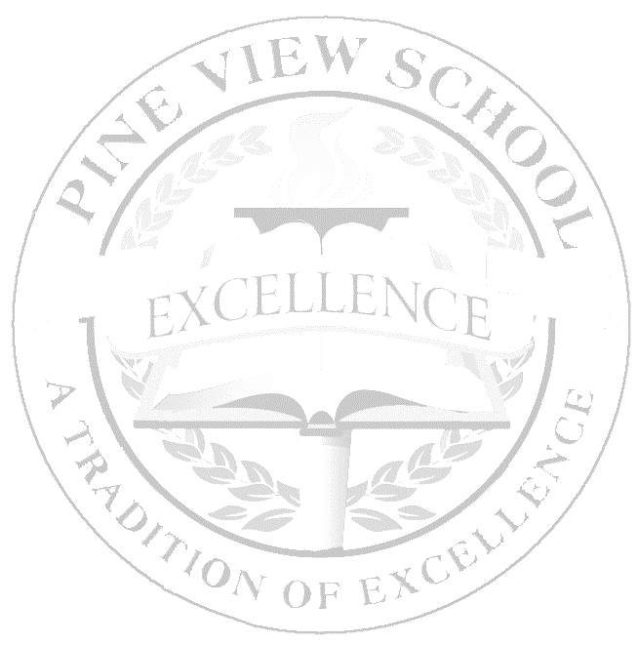
AP European History Syllabus 2020 - 2021
Mrs. Christine Braun
MLC #12

Class Description: This class introduces students to the political, economic, religious, social, intellectual, and artistic trends that shaped Europe from 1450 to the modern era. Students should acquire knowledge of the basic chronology of events and movements from this period as well as develop the ability to analyze historical documents and express historical understanding in writing. As part of the Advanced Placement program, the course prepares students for the AP European History exam. All students are expected to take the exam. MAY 7, 2021 - 12 noon.

AP European History Structure
The course is divided into 4 historical periods, linking the characteristics of these historical eras with six overarching themes that provides an analytical framework for their historical inquiry and investigations into European history. In addition to these concepts students will also learn how to build the needed historical skills and practices to become amateur historians, through the examination of primary and secondary sources.

Historical Periods
1. c. 1450 to c. 1648 3. c. 1815 - c. 1914
2. c. 1648 - c. 1815 4. c. 1914 - Present

Themes Addressed in the Course
1. Interaction of Europe and the World (INT) 4. States and Other Institutions of Power (SP)
2. Poverty and Prosperity (PP) 5. Individual and Society (IS)
3. Objective Knowledge and Subjective Visions (OS) 6. National and European Identities (NI)

History Skills and Practices Addressed in the Course
1. Analyzing Primary and Secondary Sources 4. Causation
2. Contextualization 5. Continuity and Change over Time
3. Comparison 6. Argument Development

Textbook:
A History of Western Society, Since 1300, by McKay, Hill, Buckler, Crowston, Wiesner-Hanks, Perry, Bedford, Freeman & Worth Publishing, 2017, (ISBN# 978-1-319-03598-3) 12th ed.
Supplemental Material: Board Policy 4.21.XI.B: While the textbook is the main text that is used in this course, in order to meet the intent of the standards as well as the rigor expected by the State of Florida other materials including primary source documents, political cartoons, maps, charts, videos, and graphs from repositories such as the list below may be used with in the classroom. Video from Safari or our other Learning Resources (GALE, World Book, YouTube for Education, etc.,) as well as anything packaged within digital textbook resources, may be used in our class as well. Each of these materials is aligned to the standards of the course set forth by the State of Florida.
Course Resources: We will be engaging with a wide variety of primary and secondary sources. We will also utilize, but not limited to, PBS Learning, History Channel, Library of Congress, Tom Richey AP European, Crash Course, geography and map activities, vocabulary, art, and videos.

Additional Materials:
- Spiral Notebook for class notes
- Blue or black ink pens, highlighters, pencils
- Flash drive for any computer work storage and transport
It is strongly suggested that you purchase the most recent edition of a test preparation book. The book listed below has proven to be useful in both content clarification and exam preparation:
  - Cracking the AP European History Exam: Premium Edition by The Princeton Review. ISBN 978 – 0525567509 (Amazon approx $18)
Course Format:
Guided Reading - The McKay text, although a great resource, can prove challenging to comprehend. We will therefore engage in guided reading practices throughout the year. This will require you to take notes and answer chapter review questions. Primary Source Analysis - throughout each unit, you will be expected to read, analyze, and interpret a wide variety of primary sources such as:
- Written Sources (letters, journal entries, government documents, newspapers, etc.)
- Maps
- Statistical Tables
- Works of Art
Grading and Assessment:
Unit Exams/Formal DBQ’s & LEQ’s - 50%: Unit exams will form the backbone of students’ grades. These exams will cover one unit and can include multiple choice and short answer, similar to those that students may encounter on the AP Exam. In addition to AP style questions, some exams will also include instructor‐generated questions. Point values of exams may vary according to the scope of the material covered. As the AP exam is cumulative in nature, students should be prepared to encounter cumulative elements on every exam. Chapter quizzes will be given to improve writing and recall skills. There will be a Midterm Exam at the end of the 1st semester (20%). The Final Exam will be an AP Mock Exam. This will constitute 20% of the yearly final grade. DBQ’s will be administered on an as needed basis to improve students writing skills. Full DBQs will begin around November and be assigned frequently. Mastering the skills of writing a DBQ is also vital to success on the AP exam. DBQs and LEQs will be equivalent to an exam grade once mastery is expected (2nd semester).
Classwork/Homework/Concept Guides/Projects – 30%: Each chapter/unit will have a series of persons or events that must be identified because of their significance. Review Sheets will be due each unit. These terms will assist as a study tool. Students will be responsible for chapter review questions as well. These questions, written out, will be a regular homework assignment at the end of every chapter.
Employability – 20%: In order to be successful in this course, it is imperative that students participate in class discussions, simulations, and all other assigned activities. Both quality and quantity of class participation will be considered in determining a student’s employability grade – as well as: attendance, coming to school or class on time, bringing required work tools, such as paper, pen/pencil/textbooks, notebooks, etc., completion of homework, appropriate dress for class, attitude of cooperation with teacher and fellow students, and time in class devoted to the appropriate tasks.

General Policies -
Check regularly my website (found through the school web page) has most homework.
Changes will be noted orally and on the board in class.
The School Progressive Discipline plan will be followed.
Sarasota County/school grading policy will be in effect.
No monetary donations are required.

Electronics - Cell phones may be used for instructional purposes only. Instructors will direct students to take out and put away their devices as needed. At all other times, cell phones and earbuds should not be visible/utilized during the instructional period. Teachers may elect to collect electronics during assessments or as part of their classroom procedures. Unauthorized cell phone use during class time may result in a discipline referral.

Homework and make-up work - See my website via the school web site’s Staff Directory. Homework is listed weekly on the APEH Assignments page. Following district guidelines, students are responsible for making up any work missed from absence, asking about what materials and work has been missed and making any necessary arrangements with the teacher. You must make up all work within a reasonable time, but that does not mean you may wait until the end of the quarter. You are expected to complete all make-up work for a unit before the next test. Make-up tests will not be given during class, you must make tests up at the end of the day.

After School Help: I am available for a conference 7th period. Please make an appointment to see me. I am also available through e-mail at the following addresses: Christine.Braun@sarasotacountyschools.net

Communication - If you have concerns or questions, you may contact me by email at Christine.Braun@sarasotacountyschools.net and if it is a week-day I will likely respond to you within hours or call the school 486-2001 to speak with me (work periods are 3rd & 7th).

First Semester
Period 1: 1450 - 1648 (August - September)
Chapter 11 – Summer Reading- Later Middle Ages
Chapter 12 - Renaissance
Chapter 13 - Reformation and Religious Wars
Chapter 14 - European Exploration

Period 2: 1648 - 1815 (October - December)
Chapter 15 - Absolutism and Constitutionalism
Chapter 16 - Scientific Revolution and Enlightenment – New Worldview
Chapter 17 - The Expansion of Europe
Chapter 18 - Life in the Era of Expansion
Chapter 19 - Revolutions in Politics (French Revolution and Napoleon)

Second Semester
Period 3: 1815 - 1914 (January -March)
Chapter 20 - Industrial Revolution
Chapter 21 - Ideologies and Upheaval
Chapter 22 - Life in the Emerging Urban Society
Chapter 23 - Age of Nationalism
Chapter 24 – The West and the World - New Imperialism

Period 4: 1914 - Present (March - May)
Chapter 25 - War and Revolution
Chapter 26 – The Age of Anxiety - Interwar Years
Chapter 27 – Dictatorships and the Second World War
Chapter 28 - Cold War Conflict and Consensus
Chapter 29 – Challenging the Postwar Order - End of the Cold War
Chapter 30 – Life in an Age of Globalization

“The true measure of success is not to outdo others, but rather to outdo ourselves”. At Pine View and in my classroom, this message underscores our 212 philosophy. To be successful in my classroom, putting forth extra effort, going the extra degree will have a guaranteed outcome—you will “outdo yourself”! By setting a few personal academic goals for this class and then following a plan to achieve them, you will leave this course knowledgeable, satisfied and proud of all your accomplishments....

________________________________________________________________________

Academic Integrity

At Pine View, our dedication to a tradition of excellence is based upon academic integrity. It is important that we all take academic honesty very seriously. Be assured that all assignments are carefully read and evaluated. Proper citation of research is expected.
All students are asked to abide by the following statement: “I will uphold the honor code and I understand the consequences if I choose academic dishonesty.”

I have read and understood these AP European History course expectations and agree to abide by the Honor Code of Pine View School.

Electronic Signature: Please go to the link below and fill out and digitally sign that you (the parent/guardian) have read through the syllabus and understand the expectations of this course.

https://forms.office.com/Pages/ResponsePage.aspx?id=E9pxtx3TRUedpjocyHRS0YHv_b0DsG1OsfXPOmUWIIdUNzhFSjNaQ1VZVjFZUkVWQ0pTNVdEQkZHSy4u

An Equal Opportunity Employer

