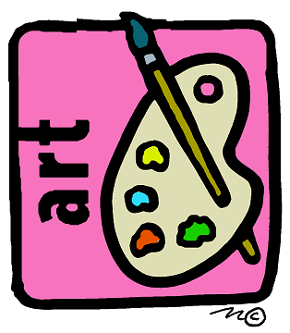

AP EUROPEAN HISTORY ART FOLIO

The study of history also requires the study of culture. You need to construct your own art book. You need to do the following for each of the listed artistic periods. You are to select at least one painting, one sculpture, and one example of architecture for each of the artistic periods. You must provide a copy of the work of art. Cite each of the works using MLA style. Explain how each of your selections exemplifies the period. You must cite your informational sources.

1. Renaissance
2. Baroque

3. Rococo
4. Neoclassical

5. Romanticism

6. Realism

7. Impressionism
8. Early 20thh century -­‐ prior to World War I
9. 1919-­‐1939 Between the Wars
10. Post World War II

